

2013 SAFENET Summary

Introduction

The SAFENET system is the interagency process designed to report “near miss,” or “close call” occurrences and other safety or health issues. These reports come from firefighters and others working on wildland fires, prescribed fires, wildland fire training, physical fitness testing, fuels treatments and all hazard incidents.

The SAFENET system was established during the 2000 fire season in response to a recommendation from Phase III of the TriData Wildland Fire Safety Awareness Study. The data collected through the SAFENET program helps identify problem areas as well as short and long term trends. SAFENET is sponsored by the National Wildfire Coordinating Group (NWCG).

The NWCG Risk Management Committee (RMC) is responsible for the management of the SAFENET program, and develops an annual summary report of SAFENETs submitted. This summary covers the calendar year January 1, 2013 through December 31, 2013.

There were 91 SAFENETs submitted in 2013, down from the 130 reported in 2012. The number of SAFENET reports submitted varies from year to year, with a high of 180 in 2005, and low of 68 in the first year of the program in 2000. The 91 reports received this year is the lowest number of reports submitted since the first year of the program.

The drop in the number of SAFENETs is probably due to two significant factors: 1) during part of the year the SAFENET submission system was not working properly and some SAFENETs that were filed by the field did not make it through the electronic process; and 2) the federal government furlough of employees at the beginning of October meant federal employees were not working on fire related activities for about three weeks.

Nationally, the 2013 fire season saw less than the 10-year average in the number of fire, and less than the 10-year average in the number of acres burned.

The following table and graph shows the number of SAFENETs filed per year since the system was established in 2000.

Total SAFENET’S Reported

2000 | 2001 | 2002 | 2003 | 2004 | 2005 | 2006
68 | 93 | 110 | 99 | 139 | 180 | 155
2007 | 2008 | 2009 | 2010 | 2011 | 2012 | 2013
118 | 143 | 123 | 155 | 117 | 130 | 91

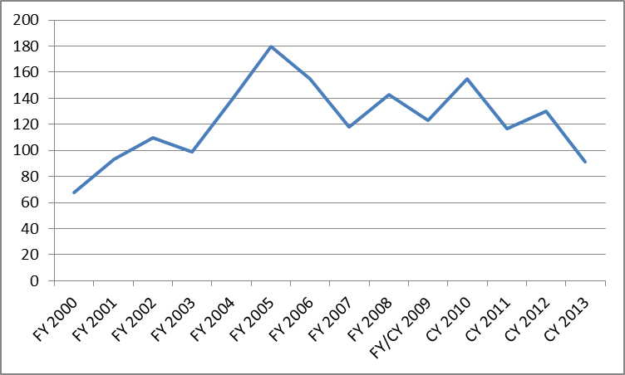

What Happens to a SAFENET?

After a wildland firefighter submits a SAFENET, it is forwarded to the national fire management safety program manager for the jurisdictional agency identified in the submission. SAFENETs cover all jurisdictions of wildland fire – national, state, and local. In addition to the five federal land management agencies, a representative from the National Association of State Foresters (NASF) is identified for SAFENET notification. The state delegate represents the interests of state, county and local fire units.

These individuals determine the course of action for the submission, which can include forwarding to the regional, state or local administrative level. The jurisdictional agency, that is the agency that owns the land where the incident took place, is responsible for reviewing the issue(s) identified, and the actions taken in the submission, and if necessary takes any additional corrective action as warranted.

This graph shows the number of SAFENETs submitted for each jurisdictional agency in 2013.

Submissions by Jurisdictional Agency 2013

USFS | BLM | States | BIA | Other | Unknown | FWS | NPS
43 | 18 | 13 | 9 | 4 | 3 | 1 | 0

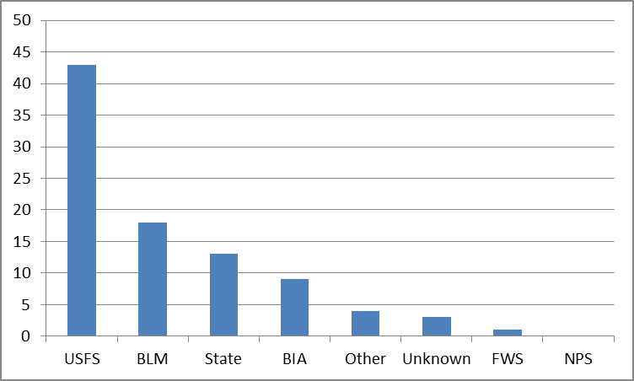

Based on percentages, in 2013 the USDA Forest Service (USFS) had the most reports with 47%, followed by the Bureau of Land Management (BLM) with 19%, and the States with 14%. The increase in the States percentages (up from 6% in 2011) could reflect a relatively higher level of fire activity on State lands in 2012. The percentage of State lands burned increased from 22% of the total in 2012, to 30% of the total in 2013. Bureau of Indian Affairs (BIA) had 10% of the submissions, the ‘Other’ category (which includes FEMA, local fire departments and counties) had 4%, Unknown had 4%, and the National Park Service (NPS) had no reports.

For the jurisdictional agencies, both the USFS and BLM showed a decrease in the number of submissions from the previous year. The States and BIA both saw an increase in numbers; while the other groups and agencies saw their submissions decrease or stay about the same from 2011.

In comparison, the following graph identifies the number of SAFENETs submissions reported by each agency for 2013.

Submissions by Reporting Agency 2013

USFS | BLM | BIA | State | Other | FWS | NPS
50 | 22 | 7 | 6 | 5 | 1 | 0

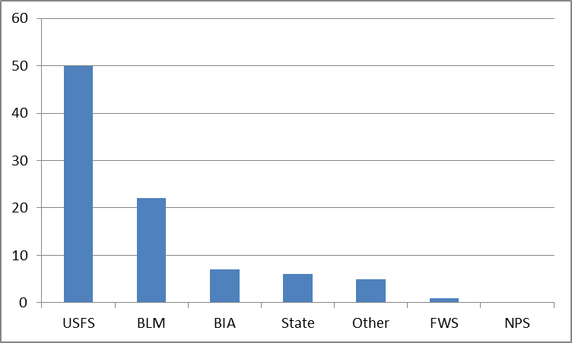

USFS and BLM employees continue to file the majority of SAFENETs. The rest of the submissions are distributed amongst the other agencies and states, and county and local fire departments which make up the “Other” category.

The table below shows the number of SAFENETs submitted by agency since the program started in 2000. The table shows the highest number submitted by each agency in a year, as well as the lowest number, the average, and total by agency.

SAFENET Submissions by Agency 2000 - 2013

Agency | Low | High | Average | Total
USFS | 27 | 94 | 58 | 810
BLM | 22 | 68 | 32 | 478
BIA | 4 | 18 | 10 | 139
NPS | 0 | 12 | 6 | 87
FWS | 0 | 13 | 3 | 48
State | 0 | 13 | 6 | 87
Other | 3 | 15 | 5 | 78
Contributing Factors

One of the important components of a safety related reporting system is the identification of contributing factors. The SAFENET system allows the submitter to choose from six different elements that may be present. These elements are: Communications, Human Factors, Equipment, Fire Behavior, Environmental, and Other. As in most years communications and human factors are the leading categories for 2013, each being mentioned in a little less than 50% of the reports.

The total number of contributing factors is 199, more than the total number of reports filed. This is because many SAFENETs because many submissions cite more than one contributing factor.

Contributing Factors by Category

Communications | Human Factors | Equipment | Environmental | Other | Fire Behavior
44 | 43 | 25 | 14 | 12 | 10

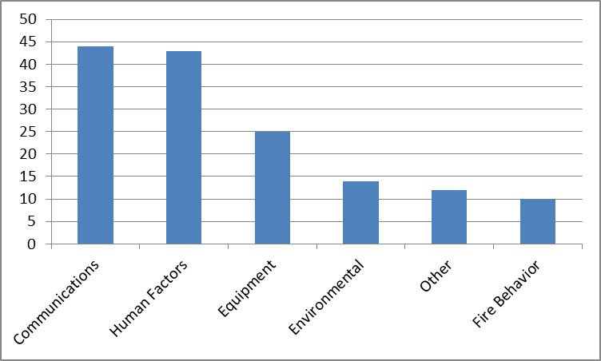

Contributing Factor Trends

The SAFENET program has been operational since 2000 and for most years, communications and human factors have been the two leading categories for SAFENET reports. As was mentioned earlier this trend continues in 2013.

In communications, there are issues with hardware (repeaters, base stations, and handhelds), frequencies, and tone lock-out for non-federal radios. After falling as a percentage in contributing factors for 4 years, this category increased for two years, and is down this year.

Human factors are consistently among the top two contributing factors for SAFENETs submitted. This category saw a 6 percent increase this year. More than other areas, this group of factors highlights the dynamic interaction of people and the fire work environment.

The number of reports listing equipment as a contributing factor increased significantly in 2012, but dropped down to previous levels, at 27 percent for 2013.

Environmental factors saw no change from 2012 numbers. Fire behavior and environment factors are often listed together on SAFENET reports.

The percentage values below were calculated by dividing the number of reports identifying a specific factor, by 91 the total number of SAFENETs filed. Again, because many reports list more than one factor, the percentages add to over 100%. For example 44 reports list communications as a contributing factor, which calculates out to be 48% of the 91 reports filed.

Communication – 48%
The majority of the submissions for communication issues dealt with radio, repeater and frequency issues. Some examples are listed below.

- Frequency allocation not monitored (2)
- Dispatch radio not transmitting (3)
- Forest radio system not working properly (2)
- Units not able to communicate because of radio incompatibility (6)
- Repeater malfunction (3)
- Aerial platform not able to communicate with dispatch (2)
- Frequency interference
- Wrong frequency listed for area response
- Problems with King radios (2)

Human Factors – 48%
This category consists of several sub-elements including Decision Making, Leadership, Situational Awareness, Risk Assessment, Performance, and Fatigue. Many of these elements are overlapping in nature and are subjective, based on the opinion of the SAFENET submitter. Below are a few examples of submissions received that exhibit each of these elements.

Decision Making
- Ranchers in area on horseback
- Returning moldy Nomex to cache

Leadership
- Supervisors on fires without PPE
- Not following work/rest guidelines
- RxB leaves unit w/o notification
- IC not qualified for fire assignment (2)
- ICT transition issues

Situational Awareness
- Hunters in Rx burn unit
- Poor briefing, lack of situational awareness
- UXO found in area

Performance
- FF wearing short boots (< 8 inches high)

Risk Assessment
- Water tender driver turns down assignment because of safety questions
- Assignment turned down, lack of mitigation for hazard trees

Fatigue and Illness
- Firefighter collapsed on line; recovered after evacuation
- Crew could not use sleeping trailer after night sift

Equipment – 27 %
Examples of equipment submissions include the following:

- Fuel cans leak
- Contract engines not having right equipment
- Not using enough straps to secure a load
- Fire in engine cab
- Re-Gen issues on diesels
- Crew carrier issues
- Hose bursting at pressure (@150 psi)

Environmental – 15%
Listed below are examples of SAFENETs that identified environmental conditions as a contributing factor:

- Steep slopes (2)
- Snags (2)

Other – 13%

- No spot weather forecast available
- Bear in camp
- Unexploded ordnance in area
- Refueling pump engine while running

Fire Behavior – 10%
A small number of SAFENETs identified fire behavior as a contributing factor. Identified below are examples:

- Fire intensity increased due to wind shift, heavy fuels

SAFENET Field Card

The Field Card is a hard copy style SAFENET to be used by firefighters for prompt reporting of safety and health concerns on wildland fire assignments, all hazard operations, or other field related work environments. This process augments, but does not replace the existing SAFENET system.

There were no Field Card SAFENET reports submitted to the national office this year. These Field Cards are intended for local or incident level use, and if the situation is corrected at the fire level, the report may not move into the system.

Incident Type

SAFENET reports allow the person to identify the type of incident where the safety concern occurred. The following pie chart identifies the percentage of incident types identified on SAFENETs for 2013. The percentage for the All Hazard category went up from 12 to 17 percent, and the SAFENETs submitted for prescribed fires and fuels treatment combined (18% this year) show a small decrease for the second year in a row. Note that some SAFENET reports list more than one incident type.

Incident Type

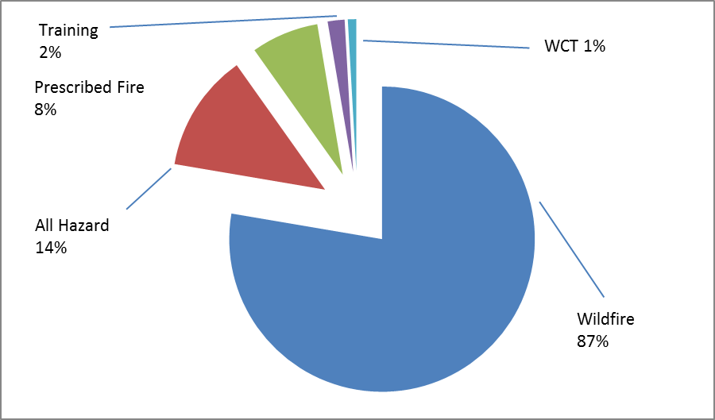

Management Level

The next chart shows the percentages of reports submitted by incident management level. Type 1 and Type 5 levels both saw significant decreases. Type 2 and Type 3 saw significant increases. Small incident organizations (Type 4 and 5) had about the same percentages of reports as larger (Type 1 and 2) incidents. Together these numbers highlight the important message that all incidents, regardless of size or management organization, can have safety and health issues.

Management Level

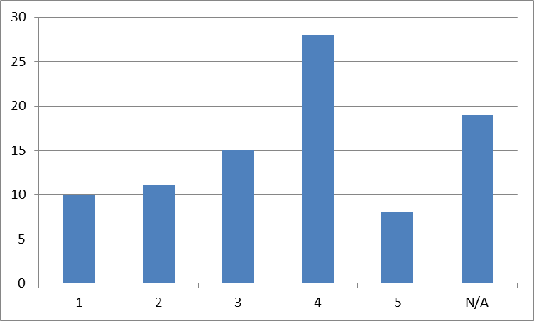

Incident Stage

As illustrated by the following chart, SAFENET reports are filed during all the stages of an event.

Incident Stage

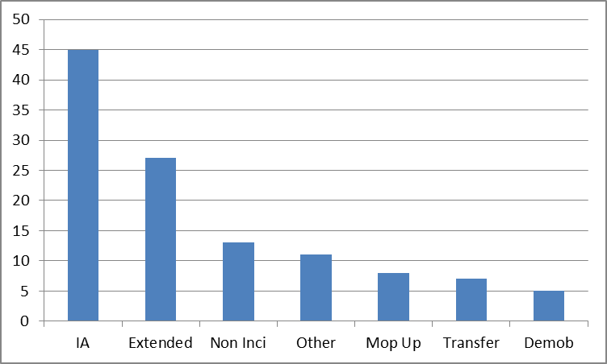

Corrective Actions

The SAFENET reporting process highly encourages that corrective actions take place at the lowest possible level, and that the SAFENET report is documenting the overall event. There are instances when additional measures are taken to address elements identified in a submission at a higher level, these are known as “Supplemental Corrective Actions.” These Supplemental Corrective Actions are tracked on the electronic version of the report. It is the responsibility of the jurisdictional agency listed in the submission to respond and provide these Supplemental Corrective Actions as warranted. This year 34% of the initial reports received follow up actions. This was an increase over the previous year.

Unpublished SAFENETs

Each year some SAFENETs that are submitted are not posted to the public website because they do not meet the establsihed criteria for SAFENET submittals. The posting criteria is avaialble on the SAFENET website (http://safenet.nifc.gov/) under SAFENET protocols.

If submittals do not meet the posting criteria, they will not be published or included in the SAFENET database. Questionable submittals are referred to the NWCG Risk Management Committee members, which includes state representatives, who manage the day-to-day operations and quality control of the SAFENET program.

In 2013 there were eight (8) SAFENETs that were not posted.

Summary

The SAFENET program was developed as a method for reporting and resolving health and safety concerns encountered by on-the-ground wildland fire personnel. It provides the opportunity to detect “weak signals,” the early warning signs of potentially dangerous conditions and actions. This is essential to safety and risk management programs so that corrective actions and other hazard mitigation measures can be taken before more serious incidents occur. The data also helps identify trends, and provides other information that is utilized by the Risk Management Committee to establish safety prevention programs and emphasis areas.

The SAFENET system does not replace the accident/injury reporting system used by specific agencies. Firefighter injuries and fire related property damage should still be reported through the respective agency processes.

The SAFENET system continues to provide a valuable link between the firefighters in the field and other levels of the fire management program. Wildland firefighters are strongly encouraged to continue submitting SAFENETs on safety and health issues as they encounter them.

Appendix A

For reference purposes, a list of incidents on which SAFENETs were filed for the 2013 season is provided below. Note: The incident name was not included on all the SAFENETs that were submitted.

Wildland Fires
Rim Fire (2) | Fairfield
Windy (2) | Cow 2
Dietrich Butte | Rancho Fire
Highland Fire | Stuart Creek 2 (3)
Cog Fire | Scriver
Picy | Bison
Butler (2) | Bingham Ridge Fire
Power Fire | 23 Mile
Nelson | North
McCan | Jim Brown
Green Ride Fire | Black Mountain
Tanacross | Marten Creek
Big Windy | East Fork Fire
Douglas Complex (2) | Keyes
Mudd Fire | Brush Creek
Doce Fire | West Fork Complex (2)
Carstens Fire | Tres Laguna
White Rock | Salt River Fire
Elephant | Hanning
Gorgonio Fire | Jarvinen Road Fire
Highway 169 | Reed Road Fire
Moose Creek | White Fire
Cedar Fire | Black Forest Fire
Robinson | Beaver Meadow
248 | Kenai Lake Fire
Dumpster | North
Bitter Creek

Prescribed Fires
Compartment 139 | Compartment 195

All Hazard, Training, & Other Incidents
Equipment transport | Electrical fire in engine
Mark Twain NF radios | Repeater malfunction
Spring fire season (4) | Dispatch
Communication system | Initial Attack
Pre-Position (2) | Fire shelters
Captains meeting | Engine Re-Gen

Appendix B

Reports by Agency 2000 to 2013

Forest Service Reporting

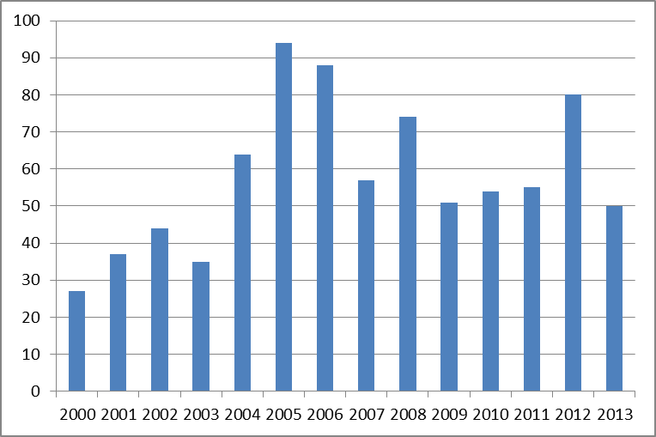

BLM Reporting

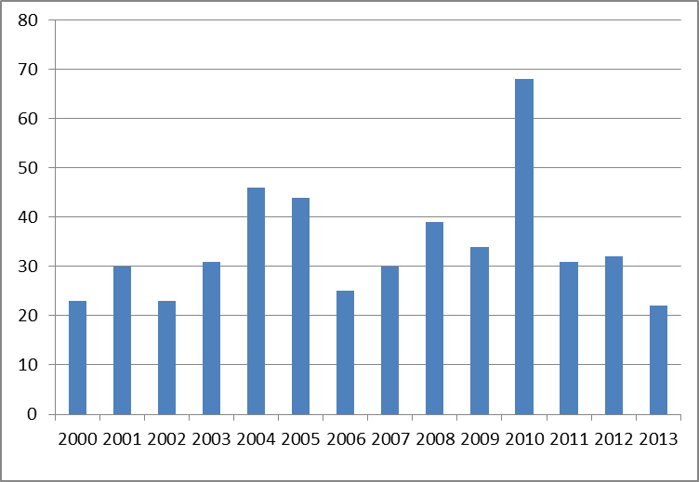

NPS Reporting

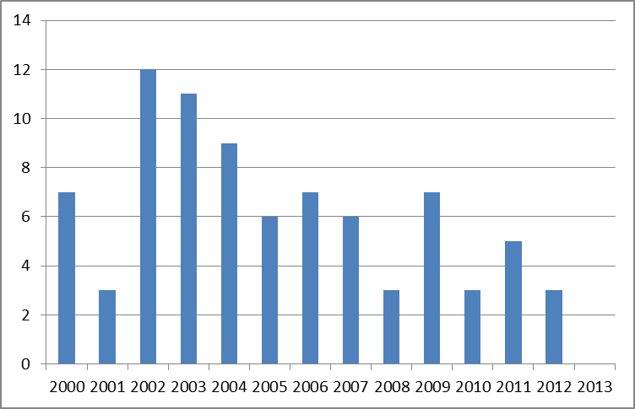

BIA Reporting

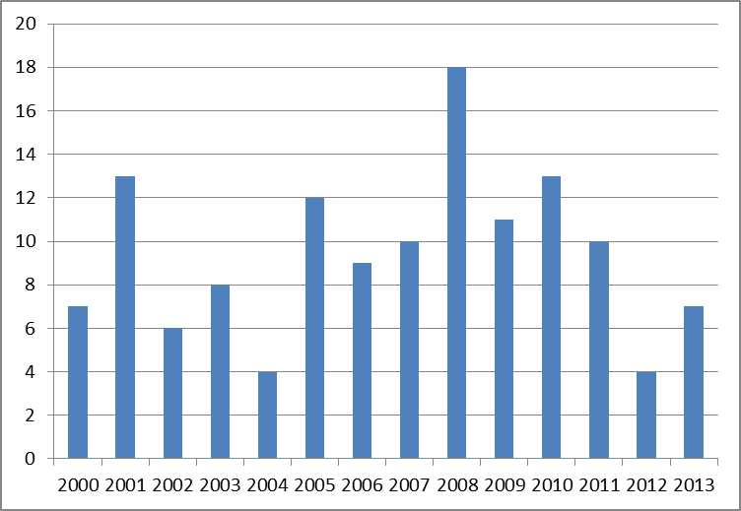

FWS Reporting

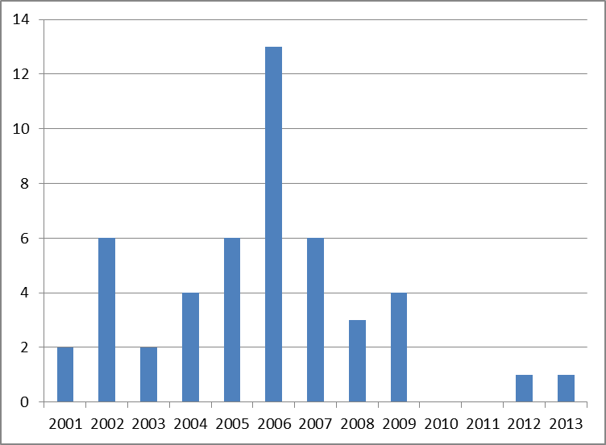

States Reporting

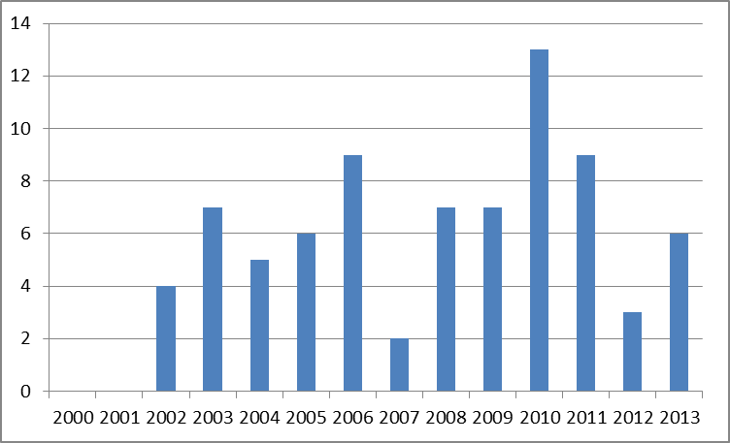

Other Reporting



