

2012 SAFENET Summary

Introduction

The SAFENET system is the interagency process designed to report “near miss,” or “close call” occurrences and other safety or health issues. These reports come from firefighters and others assigned to wildland fires, prescribed fires, wildland fire training, physical fitness testing, fuels treatments and all hazard incidents.

The SAFENET system was established during the 2000 fire season in response to a recommendation from Phase III of the TriData Wildland Fire Safety Awareness Study. The data collected through the SAFENET program helps identify problem areas as well as short and long term trends. SAFENET is sponsored by the National Wildfire Coordinating Group (NWCG).

The NWCG Risk Management Committee (RMC) is responsible for the management of the SAFENET program, and develops an annual summary report of SAFENETs submitted. This summary covers the calendar year January 1, 2012 through December 31, 2012.

There were 130 SAFENETs submitted in 2012, up from the 117 reported in 2011. The number of SAFENET reports submitted varies from year to year, with a high of 180 in 2005, and low of 68 in the first year of the program in 2000. The 130 reports received this year reflect about the 13-year average in terms of the total number submitted.

The 2012 fire season was long duration and active, and some agencies saw large increases both in hours worked and fire related injury/illnesses reports. A correlating significant increase in the number of SAFENETs filed was not seen. The lack of a large increase in SAFENET numbers could be caused by many factors: personal judgment that an event does not merit a report; a belief that someone else will do a report for the event; or, a firefighter’s lack of understanding on how the system should be used.

The following table and graph shows the number of SAFENETs filed per year since the system was established in 2000.

Total SAFENETs Reported |  | Total SAFENETs Reported
FY 2000 | 68 | 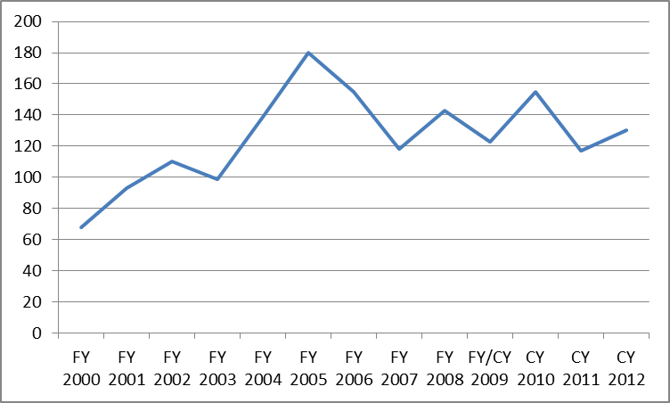
FY 2001 | 93
FY 2002 | 110
FY 2003 | 99
FY 2004 | 139
FY 2005 | 180
FY 2006 | 155
FY 2007 | 118
FY 2008 | 143
FY/CY 2009 | 123
CY 2010 | 155
CY 2011 | 117
CY 2012 | 130

What Happens to a SAFENET?

After a wildland firefighter submits a SAFENET, it is forwarded to the national fire management safety program manager for the jurisdictional agency identified in the submission. SAFENETs cover all jurisdictions of wildland fire – national, state, and local. In addition to the five federal land management agencies, a representative from the National Association of State Foresters (NASF) is identified for SAFENET notification. The state delegate represents the interests of state, county and local fire units.

These individuals determine the course of action for the submission, which can include forwarding to the regional, state or local administrative level. The jurisdictional agency, that is the agency that owns the land where the incident took place, is responsible for reviewing the issue(s) identified, and the actions taken in the submission, and if necessary takes any additional corrective action as warranted.

On the next page is a graph showing the number of SAFENETs submitted for each jurisdictional agency.

Submissions by Jurisdictional Agency 2012

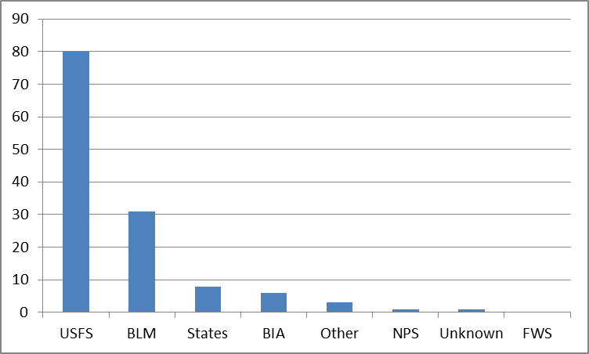

USFS | BLM | States | BIA | Other | NPS | Unknown | FWS
80 | 31 | 8 | 6 | 3 | 1 | 1 | 0

Based on percentages, in 2012 the USDA Forest Service (USFS) had the most reports with 61%, followed by the Bureau of Land Management (BLM) with 23%, and the States with 6%. The increase in the BLM percentages (up from 15% in 2011) could reflect a higher level of fire activity on BLM lands in 2012. Bureau of Indian Affairs (BIA) had 5%, the ‘Other’ category (which includes FEMA, local fire departments and counties) had 2%, and the National Park Service (NPS) and ‘Unknown’ each had less than 1%.

For the jurisdictional agencies, both the USFS and BLM showed an increase in the number of submissions from the previous year, while the other groups and agencies saw their submissions decrease or stay about the same from 2011.

In comparison, the following graph identifies the number of SAFENETs submissions reported by each agency for 2012.

Submissions by Reporting Agency 2012

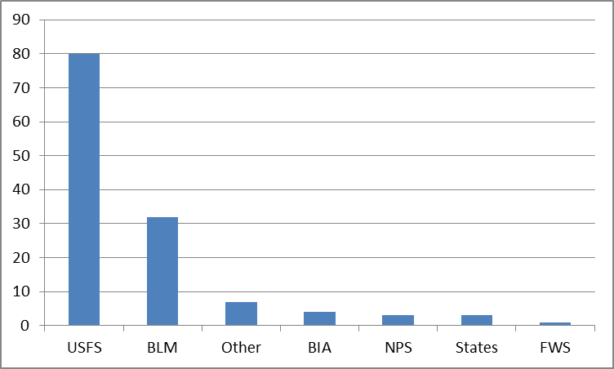

USFS | BLM | Other | BIA | NPS | States | FWS
80 | 32 | 7 | 4 | 3 | 3 | 1

USFS and BLM employees continue to file the majority of SAFENETs. The rest of the submissions are distributed amongst the other agencies and states, along with county and local fire departments which make up the “Other” category.

The table below shows the number of SAFENETS submitted by agency since the program started in 2000. The table shows the highest number submitted by each agency in a year, as well as the lowest number, the average, and total by agency.

SAFENET Submissions by Agency 2000 - 2012

Agency | Low | High | Average | Total
USFS | 27 | 94 | 58 | 760
BLM | 23 | 68 | 35 | 456
BIA | 4 | 18 | 10 | 132
NPS | 3 | 12 | 7 | 87
FWS | 0 | 13 | 4 | 47
States | 0 | 13 | 6 | 81
Other | 3 | 15 | 6 | 73

Contributing Factors - 2012

One of the important components of a safety related reporting system is the identification of contributing factors. The SAFENET system allows the submitter to choose from six different elements that may be present. These elements are: Communications, Human Factors, Equipment, Fire Behavior, Environmental, and Other. As in most years communications and human factors are the leading categories for 2012.

The total number of contributing factors is 199, more than the total number of reports filed. These is because many SAFENETs because many submissions cite more than one contributing factor.

Contributing Factors by Category

Communications | Human Factors | Equipment | Environmental | Other | Fire Behavior
66 | 54 | 44 | 15 | 11 | 9

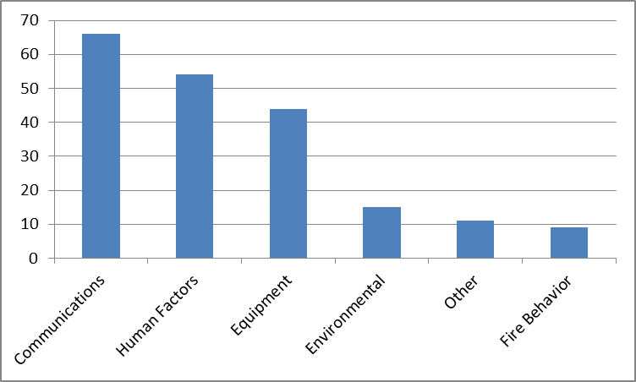

Contributing Factor Trends

The SAFENET program has been operational since 2000 and for most years communications and human factors have been the two leading categories for SAFENET reports. As was mentioned earlier this trend continues in 2012.

In communications, there are issues with hardware (repeaters, base stations, and handhelds), frequencies, and tone lock-out for non-federal radios. After falling as a percentage in contributing factors for 4 years, this category has shown an increased the past two years. This increase in percentage is matched by an overall increase in numbers for this category in 2012.

Human factors are consistently among the top two contributing factors for SAFENETs submitted. This category saw a drop in numbers for the third straight year in 2012, but still remains a strong number 2 in terms of overall contributing factors. More than other areas, this group of factors highlights the dynamic interaction of people and the work environment.

The number of reports listing equipment as a contributing factor increased significantly, from 26 in 2011 to 44 in 2012. This upturn came after two consecutive years of decreases for this category.

Environmental factors saw no change from 2011 numbers. Fire behavior and environment factors are often listed together on SAFENET reports.

The percentage values below were calculated by dividing the number of reports identifying a specific factor, by 130 the total number of SAFENETS filed. Again, because many reports list more than one factor, the percentages add to over 100%. For example 66 reports list communications as a contributing factor, which calculates out to be 50% of the 130 reports filed.

Communication – 50%
The majority of the submissions for communication issues dealt with radio, repeater and frequency issues. Some examples are listed below.

- Vertex radios not able to contact other units
- Not able to clone BK radios
- Unable to communicate with resources
- Bleed over on forest frequencies (12)
- Unable to contact dispatch (5)
- Lack of dedicated fire/dispatch frequency
- Did not hear re-call from dispatch
- National Guard helicopter with no communication with forest dispatch
- Crews and resources on divisions not able to communicate; radios would not ‘talk’ with each other
- Storm knocks out power/communications with dispatch
- Problems with radios: several involved FDs with Vertex radios that could not communicate with federal units; 2 reports of BK and Datron radios with problems transmitting and receiving
- Inadequate number of radios for resources on fire
- Tanker base radios not maintained/fixed
- North zone forest communications down, possibly due to lightning
- Incident-within-incident was using frequency assigned to another fire
- Datron VHF radio problems with scanning frequencies
- Midland radio locked up, could not transmit nor receive

Human Factors – 41%
This category consists of several sub-elements including Decision Making, Leadership, Situational Awareness, Risk Assessment, Performance, and Fatigue. Many of these elements are overlapping in nature and are subjective, based on the opinion of the SAFENET submitter. Below are a few examples of submissions received that exhibit each of these elements.

Decision Making
- Security reviews had compartments on engines locked up
- Crews return to home units from assignments worked beyond work/rest guidelines (2)
- Type 2 crew tasked as Type 2IA; crew was not qualified or equipped for assignment
- Single cab Type 6 engine staffed with three people

Leadership
- Refresher training instructor was not qualified
- Crews refusing assignments/disengaging due to un-safe conditions (4)
- Fire staff/line staff on fires without PPE (2)

Situational Awareness
- Emergency and LE staff responding to an incident without PPE (3)
- Heavy engines used in area with narrow, dead-end roads

Performance
- Lack of computer system support on the week-ends
- Teams transition, little communication with line resources

Risk Assessment
- FF hit by tree doing mop doing 100% 300 feet inside the line
- FF injured during rappelling operation to do mop up

Fatigue and Illness
- Support staff worked beyond work/rest guidelines

Equipment – 34 %
Examples of equipment submissions include the following:
- Line officer not wearing PPE on the line
- Faller using safety toe (steel toe) boots causing foot problems
- Round got stuck in the barrel of a firing pistol
- Incident used non-compliant fuel bottles
- External pump on a Type 6 would not run if pump fuel dropped below ¼ tank
- Exhaust filter on Type 6 engine filling up (re-gen issues)
- Incident used large engines on narrow roads, causing un-safe conditions when engines hit dead end
- Using ¾ helmets on UTVs makes radio use difficult
- External pump on Type 6 engine caught fire
- Tongue beam on ATV trailer hitch fails on highway
- Safety cans leaking
- Utility box on F-350 caught fire

Environmental – 12%
Listed below are examples of SAFENETs that identified environmental conditions as a contributing factor:
- Tree falling on energized power line
- Lightning causes power surge electrical line/power pole at fire camp
- Storm cell produces extreme wind event at fire camp
- Heat and humidity cause heat related illness (4)
- Heavy smoke makes working on/near road hazardous

Other – 8%
- Fuels caps on some Stihl chainsaws don’t fit properly
- Contract crew quality/behavior was below standards
- Unidentified/Unexploded ordinance causes hazards
- Polypropylene pipe melts/burns and causes holes in the road

Fire Behavior – 7%
A small number of SAFENETs identified fire behavior as a contributing factor. Identified below are examples:
- Plan was to do a burn out operation while in an inversion situation
- Potential entrapment due to rapid fire runs

SAFENET Field Card

The Field Card is a hard copy style SAFENET to be used by firefighters for prompt reporting of safety and health concerns on wildland fire assignments, all hazard operations, or other field related work environments. This process augments, but does not replace the existing SAFENET system.

There were no Field Card SAFENET reports submitted to the national office this year. These Field Cards are intended for local or incident level use, and this could be the cause of the lack of submissions.

Incident Type

SAFENET reports allow the person to identify the type of incident where the safety concern occurred. The following pie chart identifies the percentage of incident types identified on SAFENETs for 2012. The percentage for the All Hazard category went up from 12 to 17 percent, and the SAFENETS submitted for prescribed fires and fuels treatment combined (18% this year) show a small decrease for the second year in a row. Note that some SAFENET reports list more than one incident type.

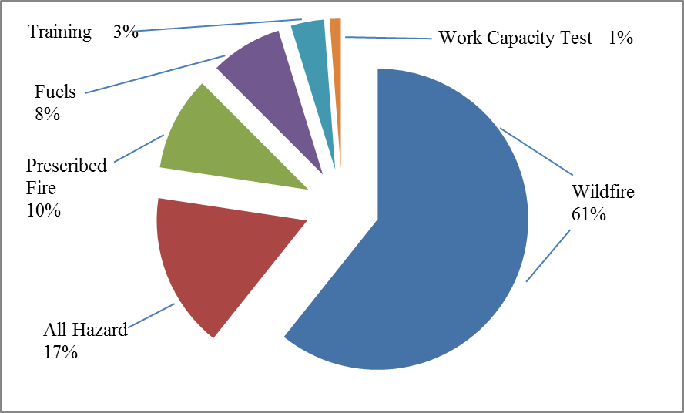

Management Level

The next chart shows the percentages of reports submitted by incident management level. Type 1 and Type 5 levels both saw significant decreases. Type 2 and Type 3 saw significant increases. Small incident organizations (Type 4 and 5) had about the same percentages of reports as larger (Type 1 and 2) incidents. Together these numbers highlight the important message that all incidents, regardless of size or management organization, can have safety and health issues.

Management Level

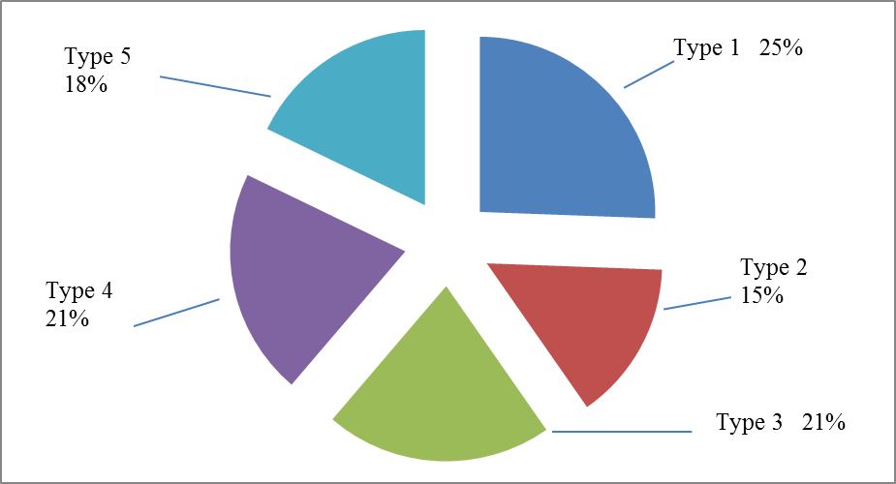

Incident Stage

As illustrated by the following chart, SAFENET reports are filed during all the stages of an event.

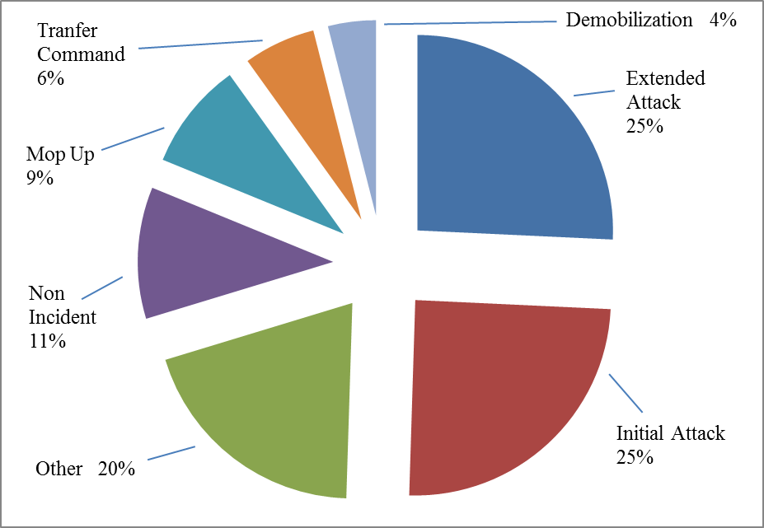

Corrective Actions

The SAFENET reporting process highly encourages that corrective actions take place at the lowest possible level, and that the SAFENET report is documenting the overall event. There are instances when additional measures are taken to address elements identified in a submission at a higher level, these are known as “Supplemental Corrective Actions.” These Supplemental Corrective Actions are tracked on the electronic version of the report. It is the responsibility of the jurisdictional agency listed in the submission to respond and provide these Supplemental Corrective Actions as warranted. This year 27% of the initial reports received follow up actions. This was an increase over the previous year.

Unpublished SAFENETs

Each year some SAFENETs that are submitted are not posted to the public website because they do not meet the establsihed criteria for SAFENET submittals. The posting criteria is avaialble on the SAFENET website (http://safenet.nifc.gov/) under SAFENET protocols.

If submittals do not meet the posting criteria, they will not be published or included in the SAFENET database. Questionable submittals are referred to the NWCG Risk Management Committee members, which includes state representatives, who manage the day-to-day operations and quality control of the SAFENET program.

In 2012 there were seven (7) SAFENETs that were not posted. Of these, two were submitted by law enfrocement (LE) personel and dealt with LE issues. The remaining five did not meet the posting criteria.

Summary

The SAFENET program was developed as a method for reporting and resolving health and safety concerns encountered by on-the-ground wildland fire personnel. It provides the opportunity to detect “weak signals,” the early warning signs of potentially dangerous conditions and actions. This is essential to safety and risk management programs so that corrective actions and other hazard mitigation measures can be taken before more serious incidents occur. The data also helps identify trends, and provides other information that is utilized by the Risk Management Committee to establish safety prevention programs and emphasis areas.

The SAFENET system does not replace the accident/injury reporting system used by specific agencies. Firefighter injuries and fire related property damage should still be reported through the respective agency processes.

The SAFENET system continues to provide a valuable link between the firefighters in the field and other levels of the fire management program. Wildland firefighters are strongly encouraged to continue submitting SAFENETs on safety and health issues as they encounter them.

Appendix A

For reference purposes, a list of incidents on which SAFENETs were filed for the 2012 season is provided below. Note: The incident name was not included on all the SAFENETs that were submitted.

Wildland Fires
Pipeline | Little Bear
East Fork (2) | Bear creek #4
County Line | Saw Mill
Lake | Shingles
Grade | Pinnacle
A-L Peak | Wood Hollow
Pahroc | Point 2
Gladiator | Sand
Moon | Arapaho
Whitewater-Baldy Complex (2) | Mill (2)
White Rock (3) | Rabbit Springs (2)
Aztec | Cache Butte
Mill and Robbers | Springs
Calf | Barry Point (2)
Chrandal Creek (2) | Chips (2)
Baboon | Tierra Blanca
Hunsinger | Iceledo
Mustang (2) | Buffalo lake
Del (2) | North Pass
Goat | Rush
Holloway | Trinity Ridge (2)
Blanco | Cache Creek
Steep Corner | Cygnet
Little Creek | Tobin
Water Falls 2 | Diamond Butte
Stafford | Gilead
McGuire Complex | Sawmill
Mile Post 66 | Pole Creek
Rio | ABCD Misc (3)
Wilson | Bagley

Prescribed Fires
Jarvis Creek Rx | Three Ranges Rx
Thinning Project | RAWS Stations
Grade | Plumas NF

All Hazard, Training, & Other Incidents
Pack Test | Colorado Severity
Travel | Wind Storm (2)
Training (2) | Dispatch
Region 2 Severity | RMCC Preposition
Security (4) | Engine Maintenance
N/A RAWS (8) | Repeater (3)
Radio (3) | Frequency/Tone (3)

Appendix B

Reports by Agency 2000 to 2012

Forest Service Reporting

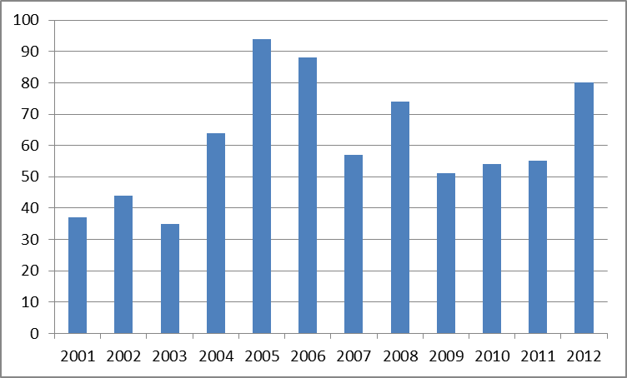

BLM Reporting

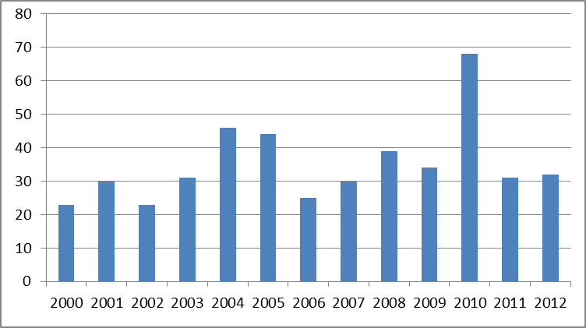

NPS Reporting

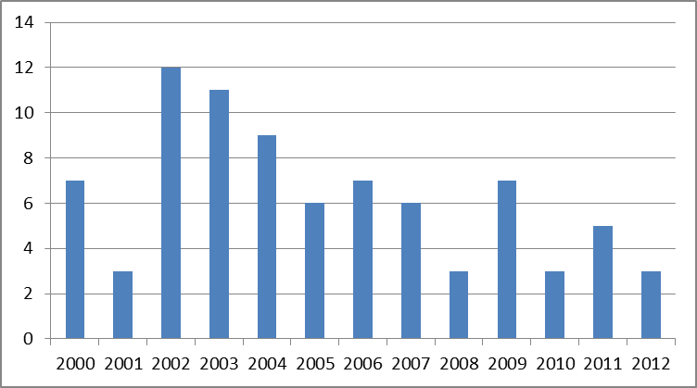

BIA Reporting

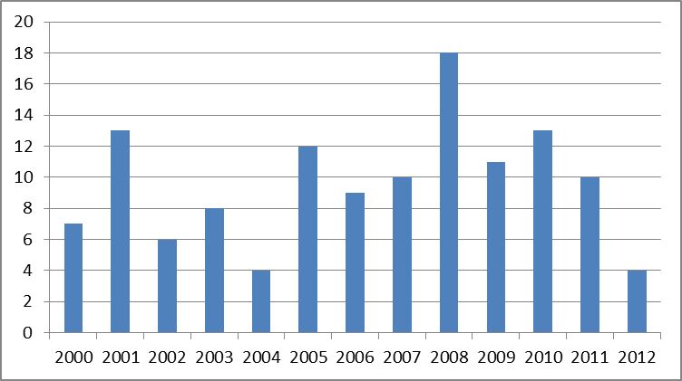

FWS Reporting

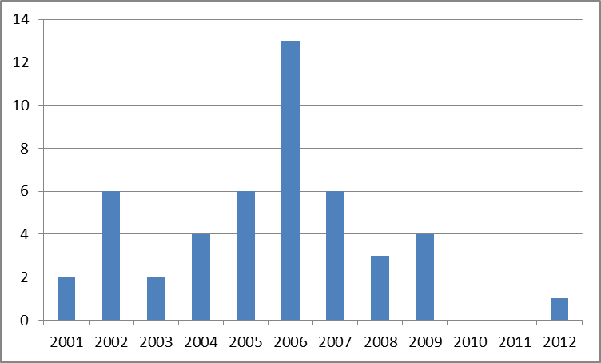

States Reporting

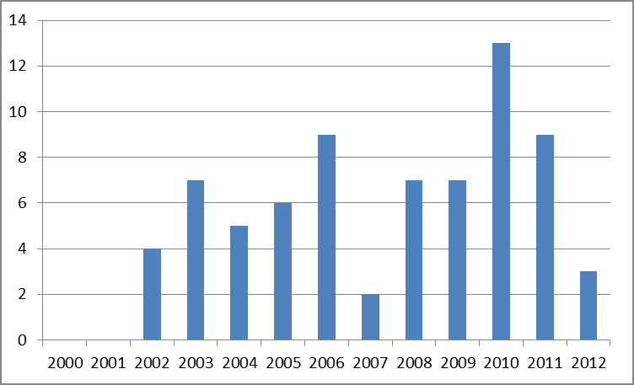

Other Reporting



